Advanced Elementary Math formula list – Grades 4-7

Fractions formulas:
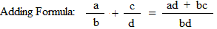
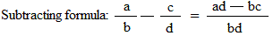
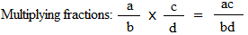
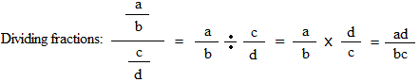
Converting a mixed number to an improper fraction:
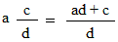
Converting an improper fraction to a mixed number:
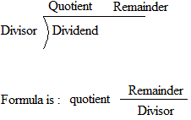
Formula for a proportion:
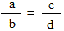
In a proportion, the product of the extremes (a * d) equal the product of the means(b*c),
Thus, a*d = b*c
Percent:
Percent to fraction: x% = x/100
Percentage formula: Rate/100 = Percentage/base
Rate: The percent.
Base: The amount you are taking the percent of.
Percentage: The answer obtained by multiplying the base by the rate
Consumer math formulas:
Discount = list price × discount rate
Sale price = list price − discount
Discount rate = discount ÷ list price
Sales tax = price of item × tax rate
Interest = principal × rate of interest × time
Tips = cost of meals × tip rate
Commission = cost of service × commission rate
Geometry formulas:
Perimeter:
Perimeter of a square: s + s + s + s
s:length of one side
Perimeter of a rectangle: l + w + l + w
l: length
w: width
Perimeter of a triangle: a + b + c
a, b, and c: lengths of the 3 sides
Circumference of a circle: $π*d$
$$d is the diameter of the circle$$Area:
Area of a square: s × s
s: length of one side
Area of a rectangle: l × w
l: length
w: width
Area of a triangle: (b × h)/2
b: length of base
h: length of height
Area of a trapezoid: (b₁ + b₂) × h/2
b₁ and b₂: parallel sides or the bases
h: length of height
Area of a circle: $π*r^{2}$
$$r is the radius of the circle$$Volume:
Volume of a cube: s × s × s
s: length of one side
Volume of a box: l × w × h
l: length
w: width
h: height

Distance
1 foot = 12 inches
1 yard = 3 feet
1 mile = 5,280 feet
1 mile ≈ 1.61 kilometers
1 inch = 2.54 centimeters
1 foot = 0.3048 meters
1 meter = 1,000 millimeters
1 meter = 100 centimeters
1 kilometer = 1,000 meters
1 kilometer ≈ 0.62 miles
Area
1 square foot = 144 square inches
1 square yard = 9 square feet
1 acre = 43,560 square feet

Volume
1 cup = 8 fluid ounces
1 quart = 4 cups
1 gallon = 4 quarts
1 gallon = 231 cubic inches
1 liter ≈ 0.264 gallons
1 cubic foot = 1,728 cubic inches
1 cubic yard = 27 cubic feet
1 board foot = 1 inch by 12 inches by 12 inches
Weight
1 ounce ≈ 28.350 grams
1 pound = 16 ounces
1 pound ≈ 453.592 grams
1 milligram = 0.001 grams
1 kilogram = 1,000 grams
1 kilogram ≈ 2.2 pounds
1 ton = 2,000 pounds
Triangle
sum of angles = 180°
area = ½ (base x height)
Circle
number of degrees in a circle = 360°
circumference ≈ 3.14 x diameter
area ≈ 3.14 x (radius)²
Simple interest
Interest ( I ) = $\frac{PRT }{100}$
Amount ( A) = Interest + Principal
Where P = Principal ( Amount invested)R = Rate of interest (%)
T = terms of investment (could be in years)

Roman numeral symbols
I=1
V=5
X=10
L=50
C=100
D=500
M=1,000

1 = I  2 = II  3 = III  4 = IV  5 = V  6 = VI  7 = VII  8 = VIII  9 = IX  10 = X | 11 = XI  12 = XII  13 = XIII  14 = XIV  15 = XV  16 = XVI  17 = XVII  18 = XVIII  19 = XIX  20 = XX  21 = XXI | 25 = XXV  30 = XXX  40 = XL  49 = XLIX  50 = L  51 = LI  60 = LX  70 = LXX  80 = LXXX  90 = XC  99 = XCIX

Average formula:
Let a₁,a₂,a₃,......,a_{n} be a set of numbers, average = (a₁ + a₂ + a₃,+......+ a_{n})/n
Converting decimals to fractions
Note the following pattern for repeating decimals:
0.22222222... = 2/9
0.54545454... = 54/99
0.298298298... = 298/999
Division by 9's causes the repeating pattern.
Note the pattern if zeros precede the repeating decimal:
0.022222222... = 2/90
0.00054545454... = 54/99000
0.00298298298... = 298/99900
Adding zero's to the denominator adds zero's before the repeating decimal.
Number Properties
(Odd)(Even) = Even
(Odd)(Odd) = Odd
(Even)(Even) = Even
(Odd) ± (Even) = Odd
(Odd) ± (Odd) = Even
(Even) ± (Even) = Even
(Positive)(Positive) = Positive
(Positive)(Negative) = Negative
(Negative)(Negative) = Positive
(Positive)/(Negative) = Negative
(Positive)/(Positive) = Positive
(Negative)/(Negative) = Positive

Number | squares | Cubes
1 | 1 | 1
2 | 4 | 8
3 | 9 | 27
4 | 16 | 64
5 | 25 | 125
6 | 36 | 216
7 | 49
8 | 64
9
10
11
12
13
14
15
16
17
18
19
20
21

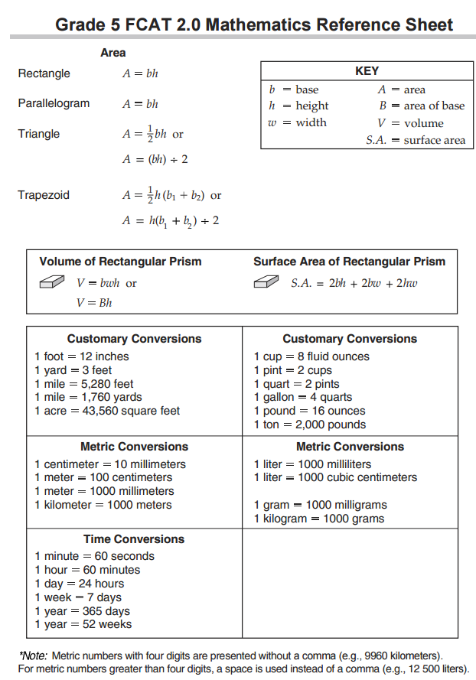
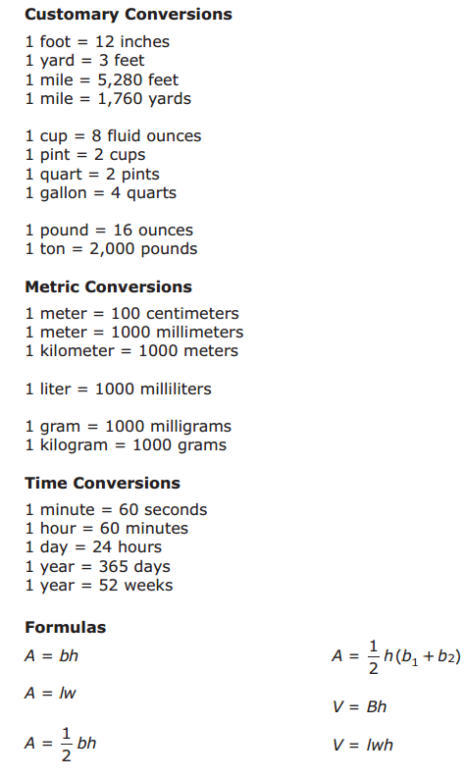
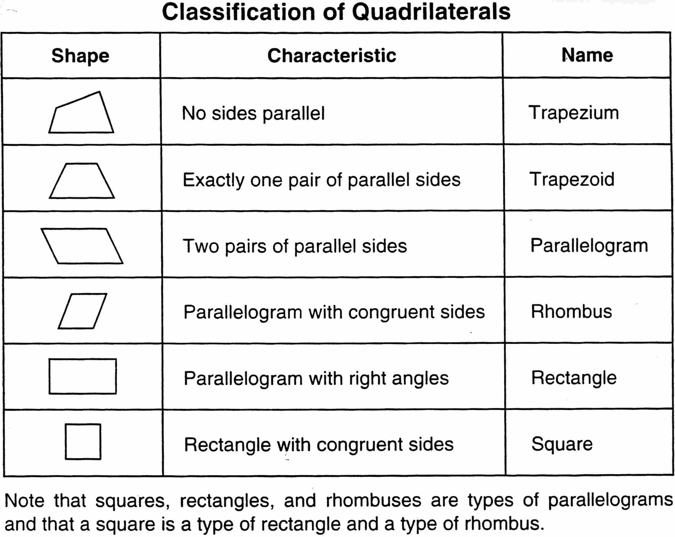
Quadrilateral

Square
Rectangle
Parallelogram
Isosceles Trapezoid
Trapezoid
Rhombus
Kite

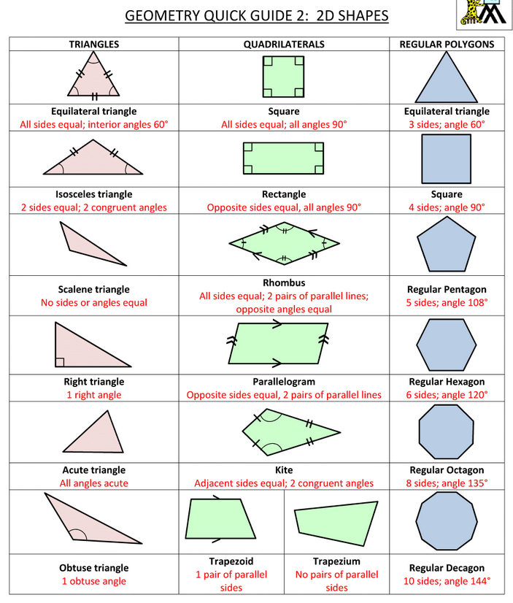

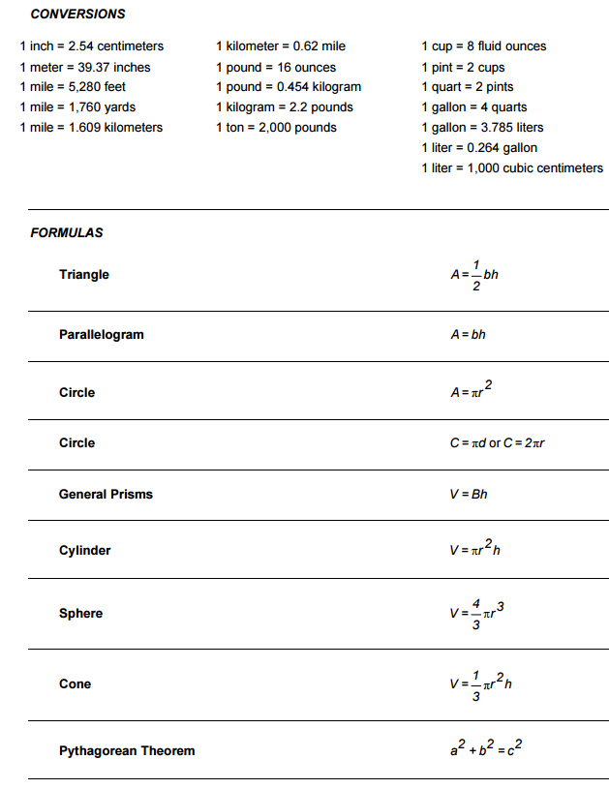

Here is a list of all the prime numbers up to 1,000:
2 | 3 | 5 | 7 | 11 | 13 | 17 | 19 | 23 | 29 | 31 | 37 | 41 | 43 | 47 | 53 | 59 | 61 | 67
71 | 73 | 79 | 83 | 89 | 97 | 101 | 103 | 107 | 109 | 113 | 127 | 131 | 137 | 139 | 149 | 151 | 157 | 163
167 | 173 | 179 | 181 | 191 | 193 | 197 | 199 | 211 | 223 | 227 | 229 | 233 | 239 | 241 | 251 | 257 | 263 | 269
271 | 277 | 281 | 283 | 293 | 307 | 311 | 313 | 317 | 331 | 337 | 347 | 349 | 353 | 359 | 367 | 373 | 379 | 383
389 | 397 | 401 | 409 | 419 | 421 | 431 | 433 | 439 | 443 | 449 | 457 | 461 | 463 | 467 | 479 | 487 | 491 | 499
503 | 509 | 521 | 523 | 541 | 547 | 557 | 563 | 569 | 571 | 577 | 587 | 593 | 599 | 601 | 607 | 613 | 617 | 619
631 | 641 | 643 | 647 | 653 | 659 | 661 | 673 | 677 | 683 | 691 | 701 | 709 | 719 | 727 | 733 | 739 | 743 | 751
757 | 761 | 769 | 773 | 787 | 797 | 809 | 811 | 821 | 823 | 827 | 829 | 839 | 853 | 857 | 859 | 863 | 877 | 881
883 | 887 | 907 | 911 | 919 | 929 | 937 | 941 | 947 | 953 | 967 | 971 | 977 | 983 | 991 | 997 | more...

